**Hot Drinks Cooling**

**Assignment**

**Scientific Report**

**Name: ______________________**

**Class: ________**

**Log Book – Hot Drinks Cooling**

**Aim:**

*What you want to achieve in the experiment?*

________________________________________________________________________________________________________________________________________________________________________________________________

**Independent variable:** *(change)* __________________________

**Dependent variable:** *(measure)* ___________________________

**Controlled variable:** *(same)* ________________________________________________________________________________________________________________________________________________________________________________________________

**Hypothesis:**

If ______________________________________________________________ then____________________________________________________________

**Materials and method**:

|  |  |
| --- | --- |
|  |  |
|  |  |

**Diagram:**

*Draw a scientific diagram of your set up.*

**Table:**

*In the space below please construct a table of your results.*

**Graph**

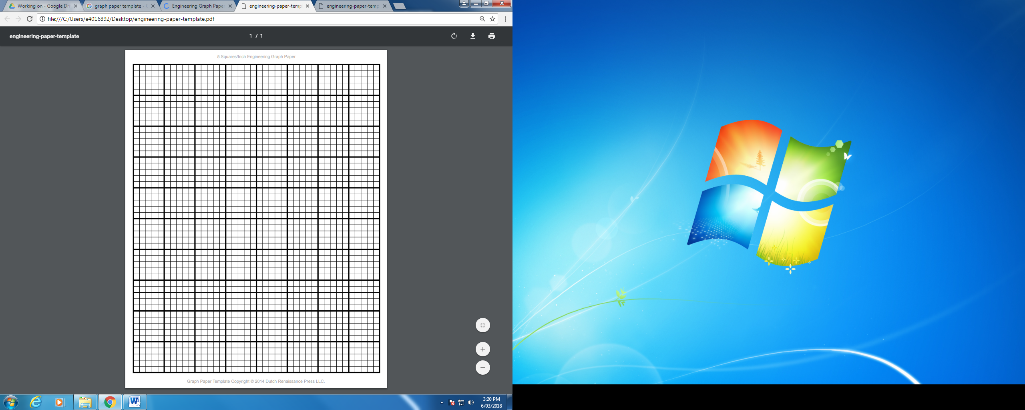

**Discussion**

*Which drink cooled the fastest?*

________________________________________________________________

*Which drink cooled the slowest?*

________________________________________________________________

*Describe the trend or pattern that each graph showed. Was it increasing, decreasing or unpredictable?*

________________________________________________________________________________________________________________________________

*Explain why the drinks cooled at different rates.*

________________________________________________________________

________________________________________________________________________________________________________________________________________________________________________________________________

**Conclusion**

*Summarise what you discovered at the end of the experiment.*

________________________________________________________________

________________________________________________________________

**Evaluation**

*Were there any problems when you were conducting your experiment?*

________________________________________________________________

________________________________________________________________________________________________________________________________

*What improvements could be made to the experiment?*

________________________________________________________________

________________________________________________________________

________________________________________________________________

**Total: /30**